VIA NOVA CHILDREN’S SCHOOL

TUITION PAYMENT AND FEES

Tuition for September 2018 to August 2019:
2 years old/Beluga 5 days/week $21,600 year, in monthly installment of $1,800
4 days/week $20,400 year, in monthly installment of $1,700

3 years old/Lion Cubs 5 days/week $19,920 year, in monthly installment of $1,660
4 days/week $18,720 year, in monthly installment of $1,560

4 years old/Dinosaurs 5 days/week $19,200 year, in monthly installment of $1,600
4 days/week $18,000 year, in monthly installment of $1,500

Tuition payments are due on the first day of each month with a five-day grace period before payments are considered late. If paying after the 5th of the month, please add the late fee of $20.00 to your total. A $25.00 fee will be charge for returned checks. The drop-in fee is a $80.00 day.
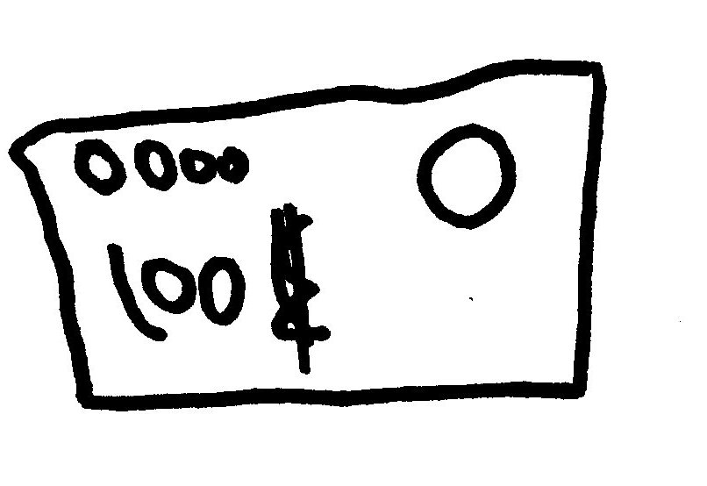
One Time and Annual Fees:
Application Fee $25.00
Last Month Deposit Equal to one month’s tuition
Annual Earthquake Fee $25.00
Yearly Material Fee $200.00
Late Pick-up Fee $1 each minute
Late fee for Monthly Tuition $20.00 after the 5th of the month
Return Check $25.00

